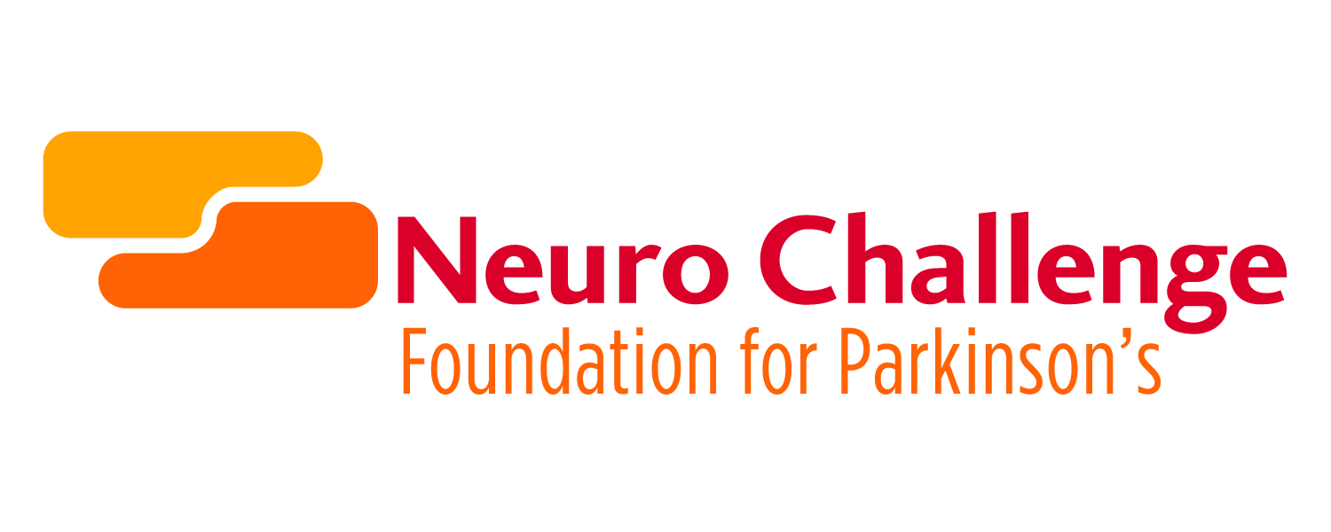
Job Description
Development Director
PERSONAL TRAITS
- Passion, advocacy and excitement for the mission of the Neuro Challenge Foundation for Parkinson’s
- Intellectual curiosity, confidence and ability to apply the experience of innovative & creative development skills to an organization that will transform lives forever.
- Transparent Communication
- Poise, credibility and relationship skills to work with all constituencies
- Strong personal work ethic with a sense of humor and perspective
- Entrepreneurial, creative style
- Integrity and honesty
- Team-orientated and mission-driven professional with a desire to create and build
- Collaborative

DUTIES AND RESPONSIBILITIES
- Develop and implement a comprehensive fundraising plan in partnership with the CEO
- Serve as the organization’s major gift fundraiser, identifying, cultivating, soliciting and stewarding key donors and prospects
- Build a strong portfolio of major gift prospects and donors working with the CEO
- Develop a data base of donors and prospects
- Oversee the Event Manager and maintain all special events
- Develop and implement an ongoing annual giving program
- Coordinate & review all Philanthropic Communications for quality messaging
- Ensure and maintain the Culture of Philanthropy throughout the organization
- Supervise an external Marketing plan which includes creating a Philanthropic website, newsletters and social media campaign
- Remain up-to-date on current fundraising, being used in the nonprofit sector as well as current tax law affecting charitable giving
- Ensure the financial goals of philanthropy are met
- Act as an advocate for the agency in activities and in making presentations to promote the mission and goals of the agency

Ideal Candidate
- A deep, abiding passion for the mission and goals of the agency
- Belief and support in donor-centered philanthropic culture
- Proven ability to articulate a compelling vision and inspire board, staff, donors, volunteers and public to achieve it
- High emotional intelligence and ethical standards
- A high degree of self-motivation, ingenuity, and creativity
- Open minded, adaptable and collaborative
- Ability to maintain positive and authentic relationships
- Experience, comfort and confidence in asking for and closing major gifts
- Enjoy working in a fast-paced, dynamic and quickly changing environment
- Highly organized with attention to detail
- Excellent at follow-through and donor customer service
- Commitment to diligently documenting contact information, prospect research, and interaction reports
- Excellent verbal and written communication skills
- Ability to write clear, concise, and compelling proposals, letters, reports and supervise grants
- Proficient in donor management software
- Willingness to be mentored and/or mentor others

Qualifications
Minimum qualifications include a bachelor’s degree, 3 to 5 years of development or related work experience, and demonstrated success in marketing, communications, and fundraising. A background in either a for profit or non-profit environment in a staff position or volunteer leadership role is a plus. Healthcare experience and CFRE is a plus.
Submit letter of interest and resume along with salary expectation to karen@mbjgroup.com by April 5, 2019

Neuro Challenge Foundation for Parkinson’s (NCF) is a local 501 c 3 non-profit organization dedicated to improving the quality of life of people with Parkinson’s and their caregivers. We accomplish our mission by providing monthly education, support and therapeutic programs; individualized care advising; community resource referrals; and semi-annually held medium to large scale educational events. All services and programs are provided at no charge thanks to the generosity of the communities we serve.

